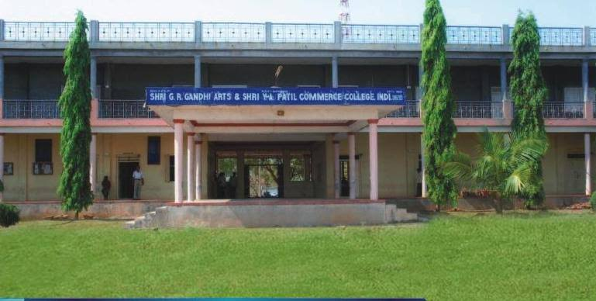

CRITERION VII – INSTITUTIONAL VALUES AND BEST PRACTICES Key Indicator - 7.1 Institutional Values and Social Responsibilities
7.1.2 The Institution has facilities for alternate sources of energy and energy conservation measures
1.Solar energy
2.Biogas plant
3.Wheeling to the Grid
4.Sensor-based energy conservation
5.Use of LED bulbs/ power efficient equipment
7.1.2 The Institution has facilities for alternate sources of energy and energy conservation measures
1.Solar energy: Solar energy is a powerful source of energy that can be used to heat, cool, and light homes and businesses. More energy from the sun falls on the earth in one hour than is used by everyone in the world in one year. A variety of technologies convert sunlight to usable energy for buildings. The most commonly used solar technologies for homes and businesses are solar photovoltaics for electricity, passive solar design for space heating and cooling, and solar water heating. Solar Panels not installed in our campus.
2.Biogas plant: Biogas is a clean and efficient fuel. Biogas is produced from Cattle Dung, Human Excreta and other organic matter in Biogas plant through a process called 'Digestion'. Biogas contains 55% to 60% methane which is inflammable. It also contains 30% to 35% carbon dioxide and traces of Nitrogen, Hydrogen and Water. Bio slurry which is bye product has manurial value than farm yard manure. Biogas plant not Installed in Our Campus.
3.Wheeling to the Grid: Wheeling is the movement of electric energy from within an electrical grid to an electrical load beyond the grid borders in electric power transmission. There are two forms of wheeling: 1) a wheel-through, in which the electrical power generation and load are both outside the transmission system's borders, and 2) a wheel-out, in which the generation resource is inside the transmission system's limits but the load is outside. Wheeling to the Grid facility is not available in Our Campus
4.Sensor-based energy conservation: Sensor-based energy conservation has drawn attention of many places because of the reduced cost, easy mobility, easy maintenance, power management etc. But Sensor based systems has not installed in our campus.
5.Use of LED bulbs/ power efficient equipment: The College is using CFL, LED and star rated power equipments etc. which consume lesser electricity vis-a-vis illumination and result in lesser energy utilization. College procures electrical equipments which have energy star rating as per Bureau of Energy Efficiency (BEE) standard which ensure relatively lesser consumption of electricity. The College has installed the LED light in the whole campus for low consumption of energy and replace the old light systems. We use of LED bulbs/ power efficient equipment for better power management.
USE OF LED BULBS AND CC CAMERA 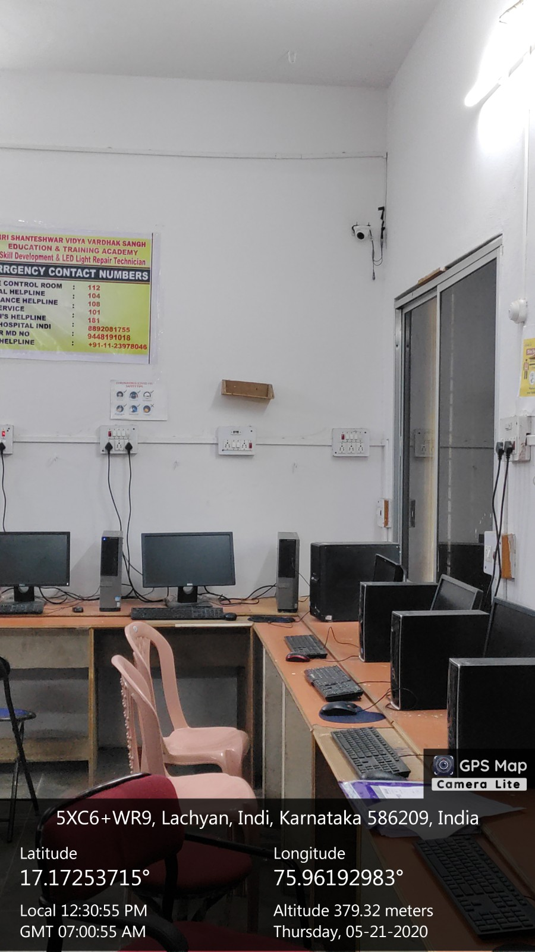
USE OF LED BULBS IN STAFF REST ROOM
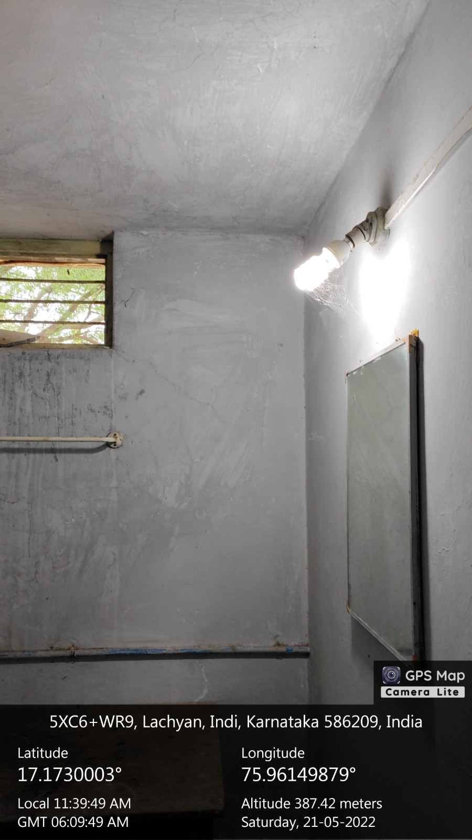

USE OF LED BULBS :
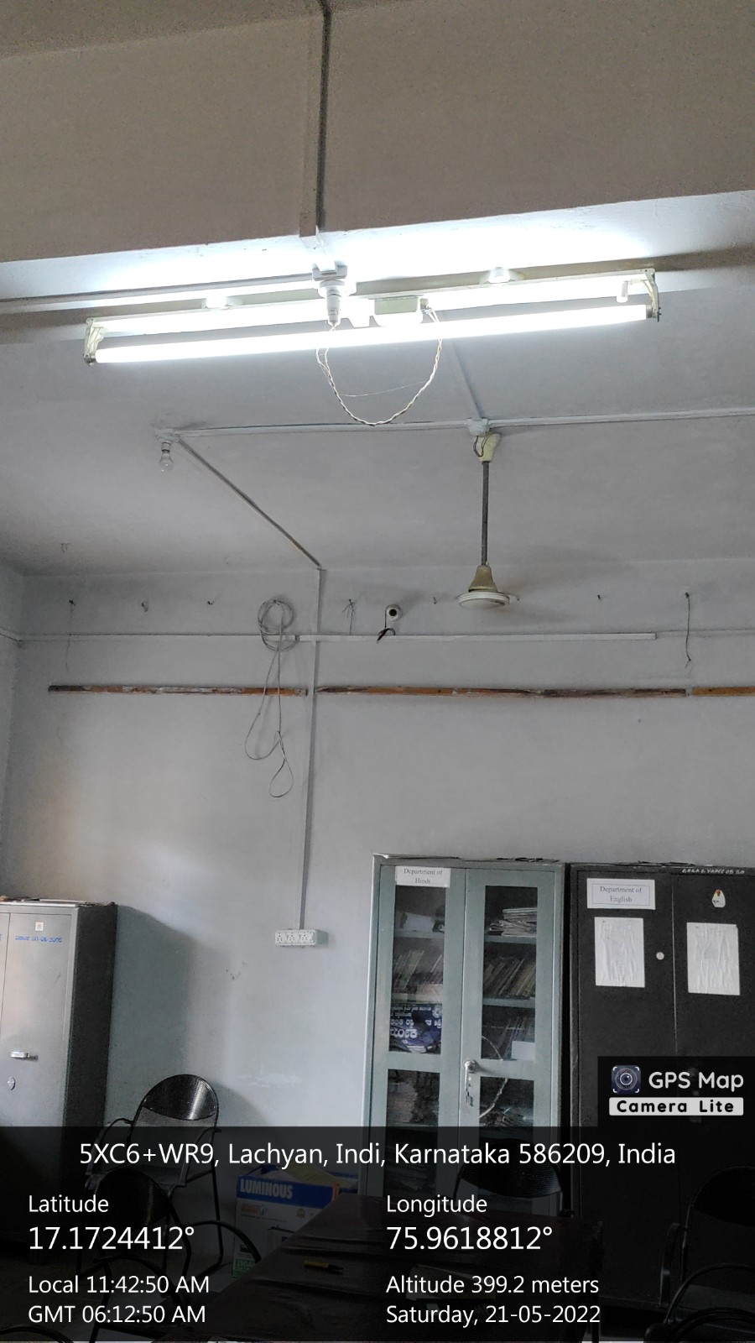

USE OF LED &CFL BULBS IN PRINCIPAL ROOM
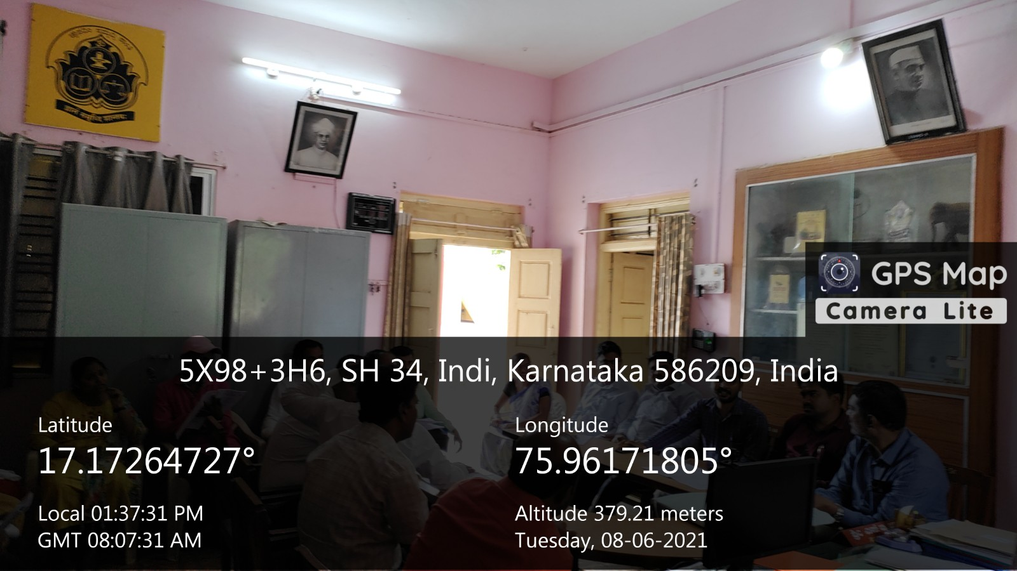

USE OF LED BULBS
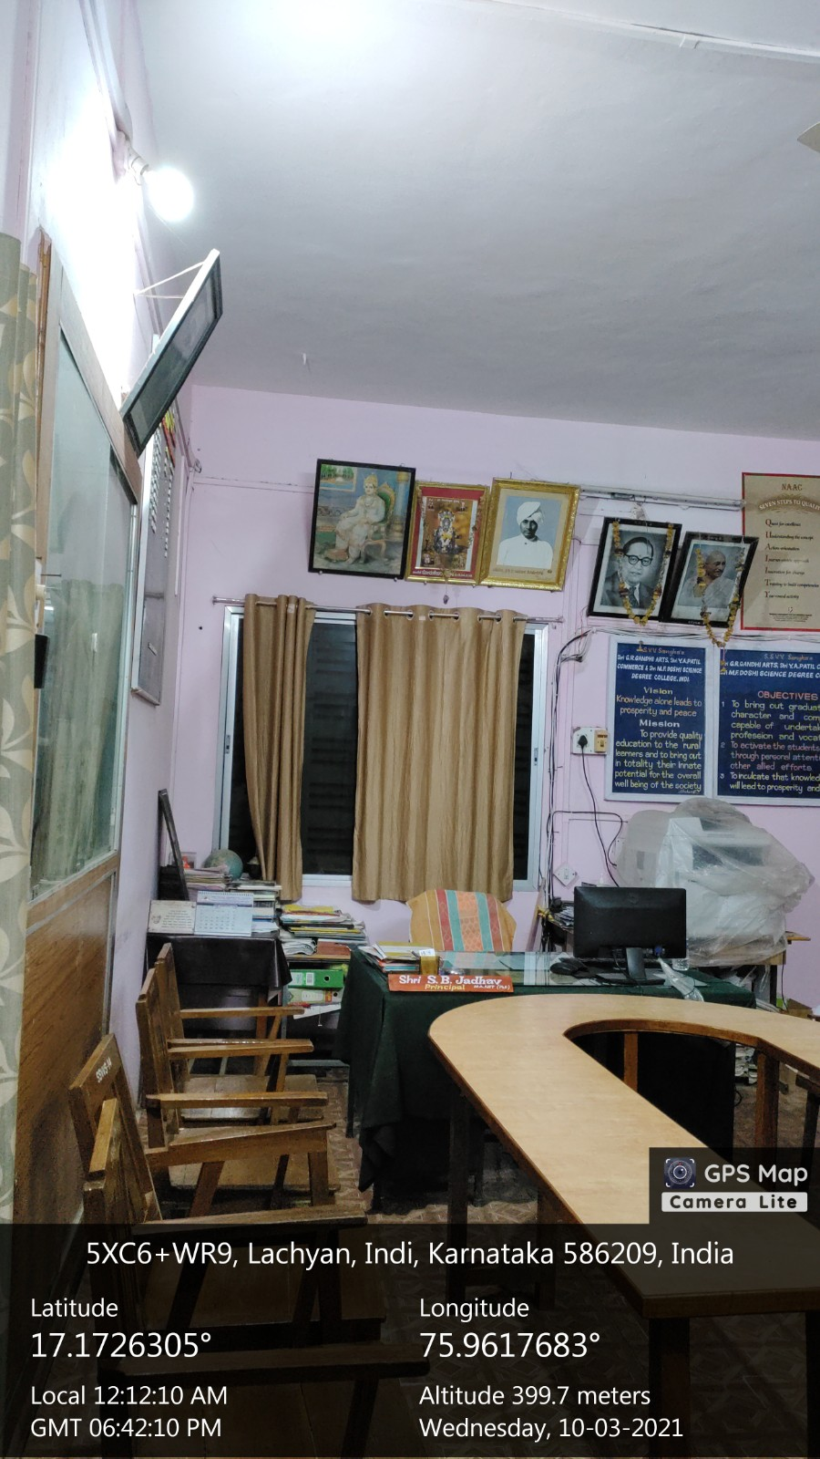

LED BULBS AND CAMERA SURVIVALANCE
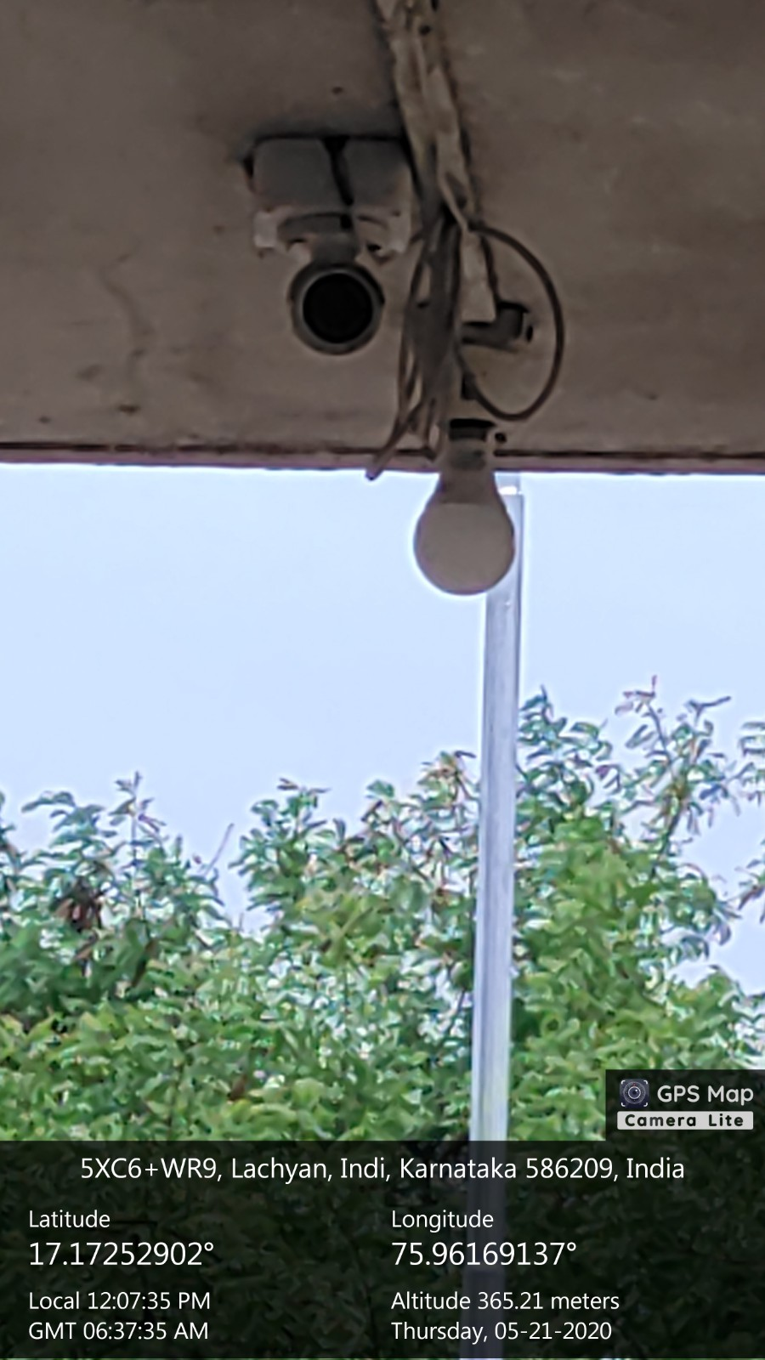

POWER EFFICIENT EQUIPMENT
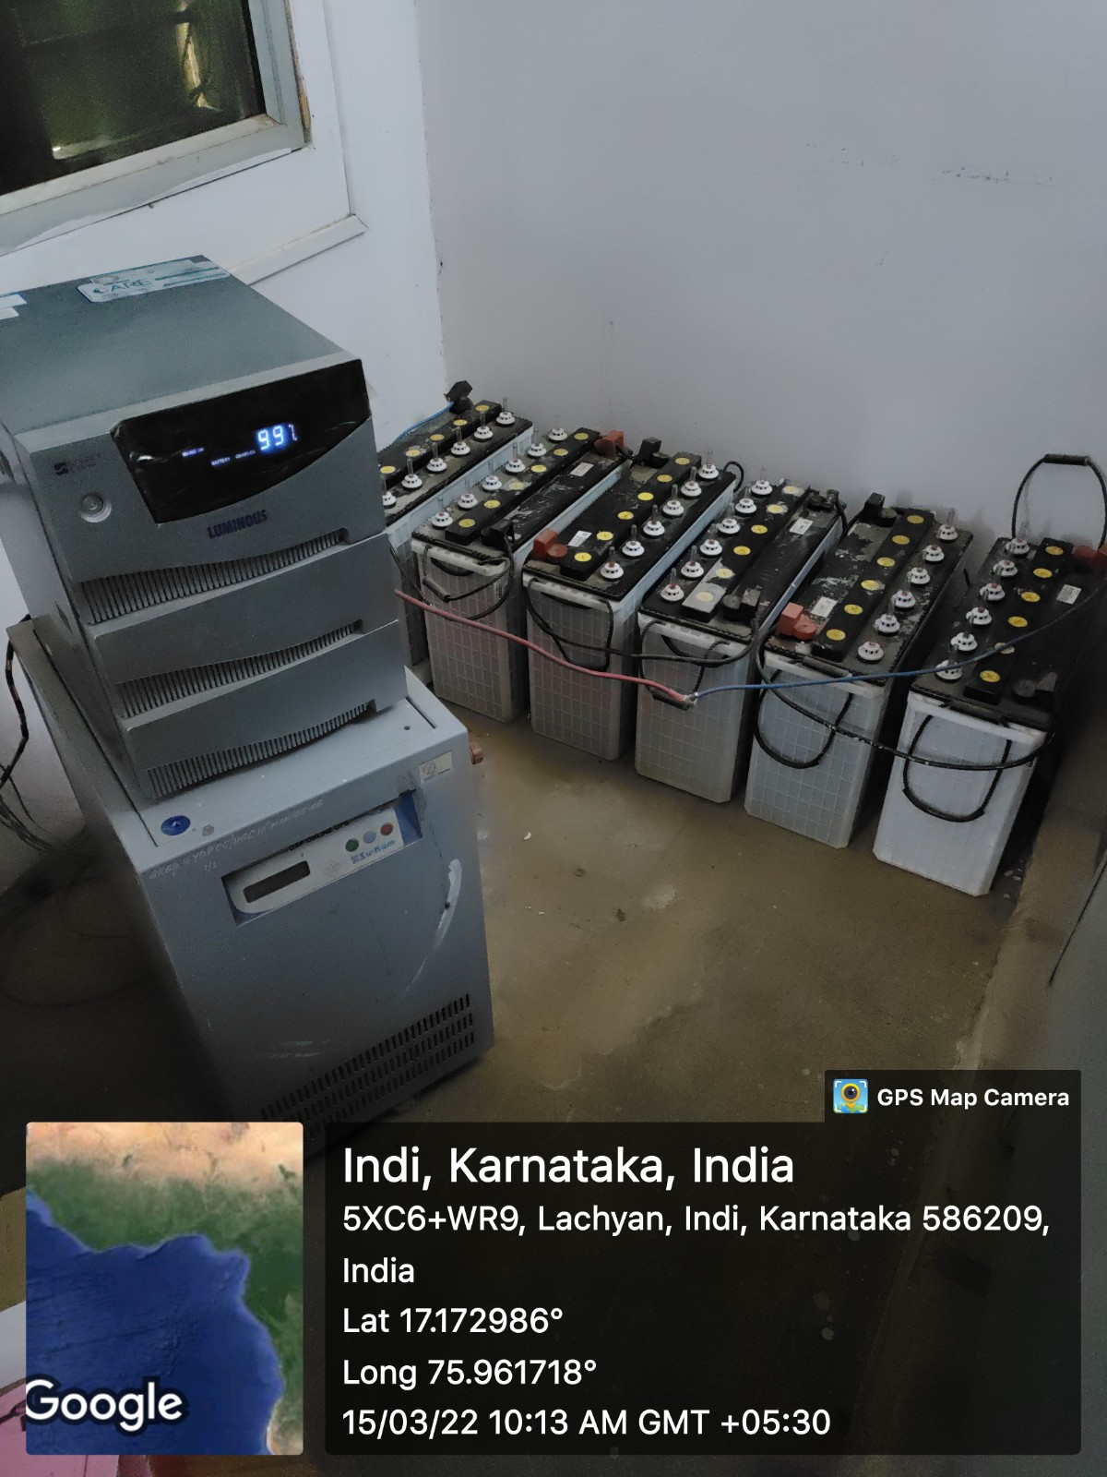
POWER EFFICIENT EQUIPMENT
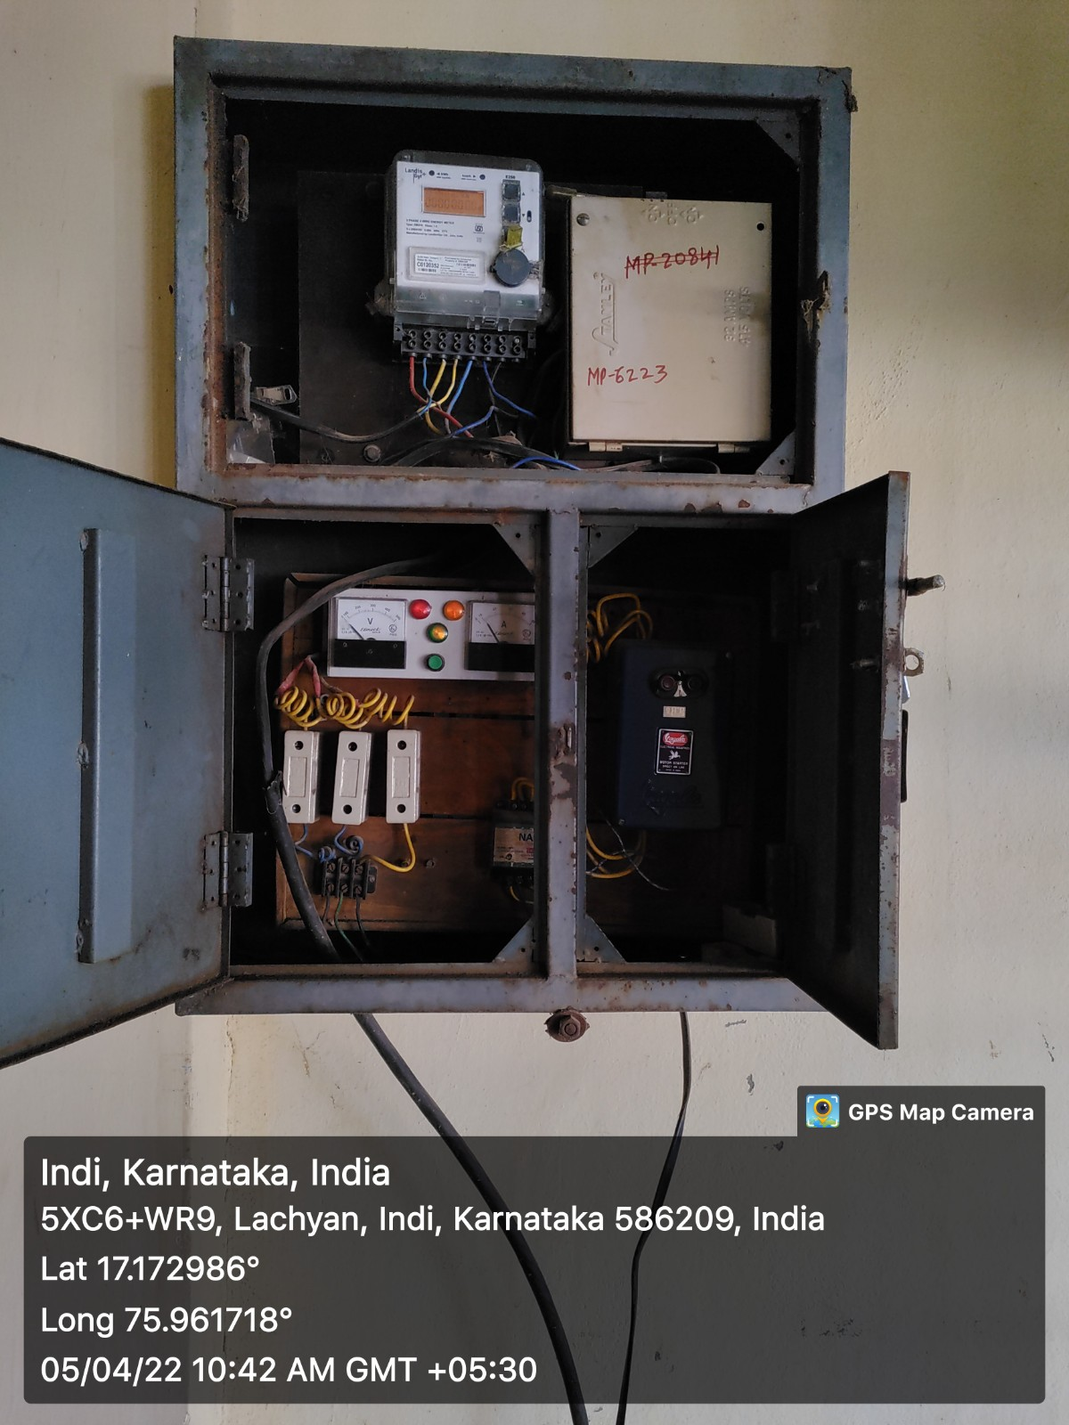

BILL FOR LED BULBS
